
DHARMSINH DESAI UNIVERSITY, NADIAD
FACULTY OF MANAGEMENT AND INFORMATION SCIENCE
B.C.A. SEMESTER VI
SUBJECT: (25BCA601)SYSTEM DEVELOPMENT PROJECT
Student Name | Himanshu D Ladha
Roll No | BCA045
Student ID | 23BCUOS055

Project Definition: RestoFlow – A full-stack Restaurant Management Platform.

Company Timing: 11:00 AM to 6:00 PM

Week | Date | Day | Name of the Topic | Signature
Eleventh Week | 09-02-2026 | Monday | Redraw the data flow diagram
Eleventh Week | 10-02-2026 | Tuesday | Draw the Entity relationship diagram
Eleventh Week | 11-01-2026 | Wednesday | --Leave--
Eleventh Week | 12-01-2026 | Thursday | Draw the system flow chart
Eleventh Week | 13-01-2026 | Friday | Created data dictionary

External Guide Name: Somil Sir Internal Guide Name: Prof. Rupal Patel
Signature Signature

09-02-2026
- Context Level DFD
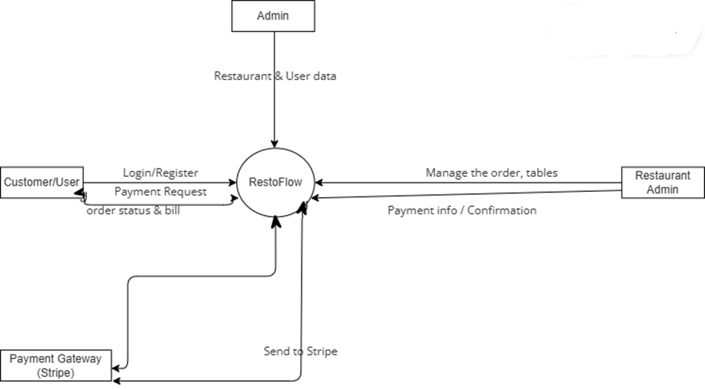
- Level 1 DFD
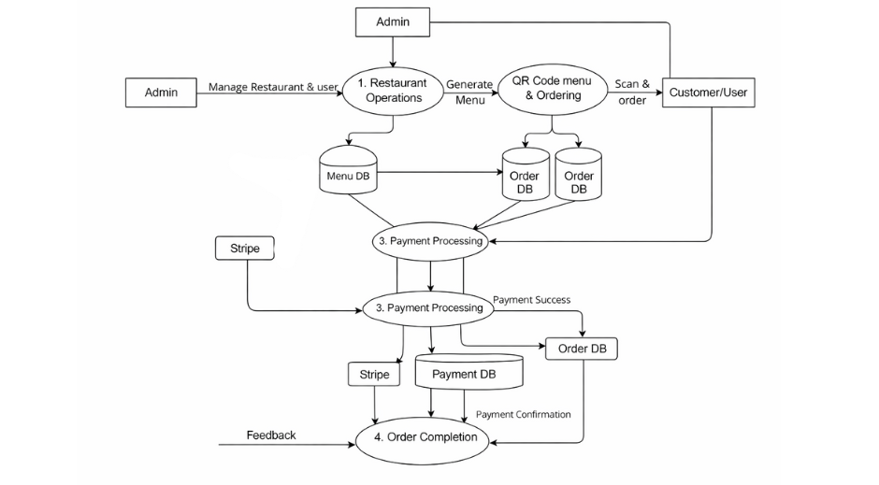
- Level 2 DFD
  - 1. User Management
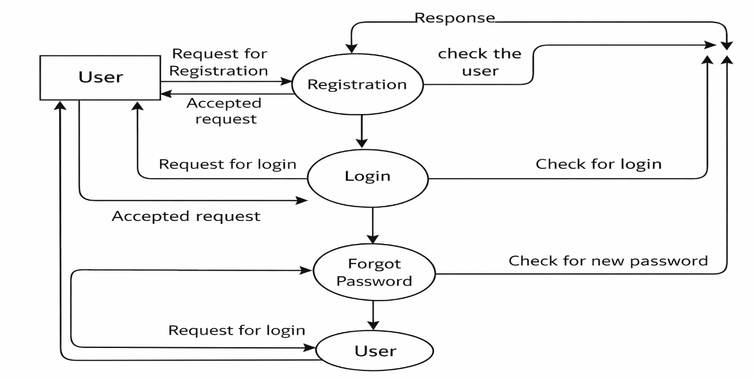
- 2. Food Management
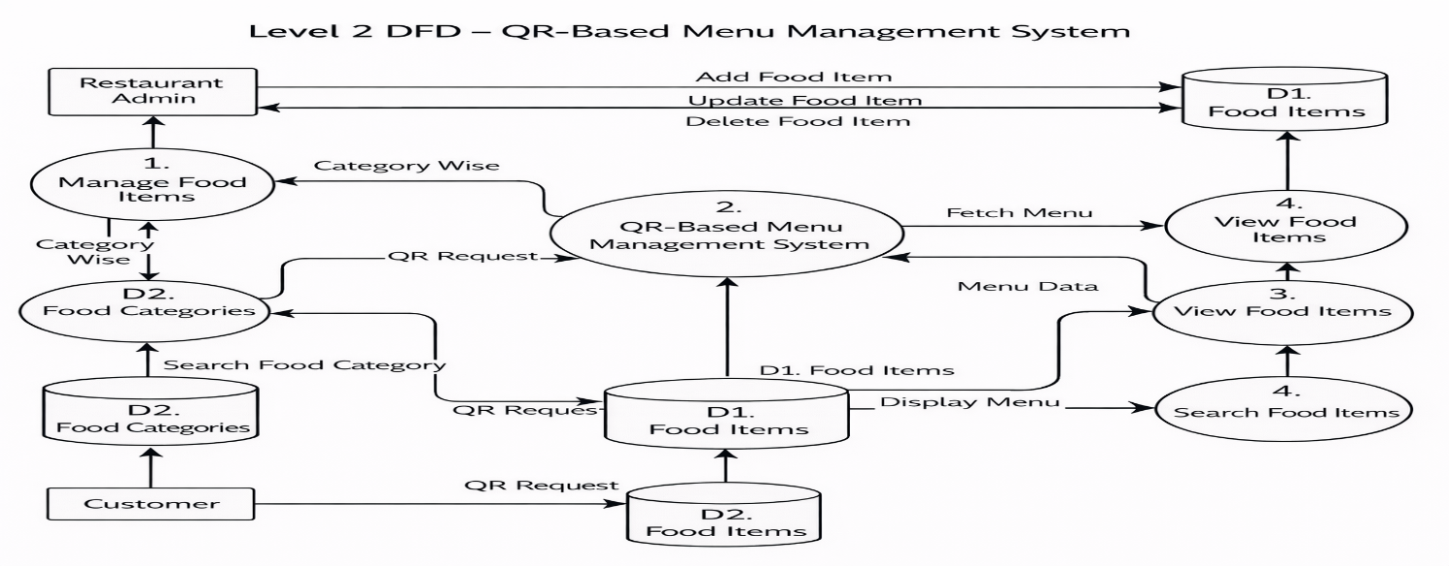
- 3. Reservation Management
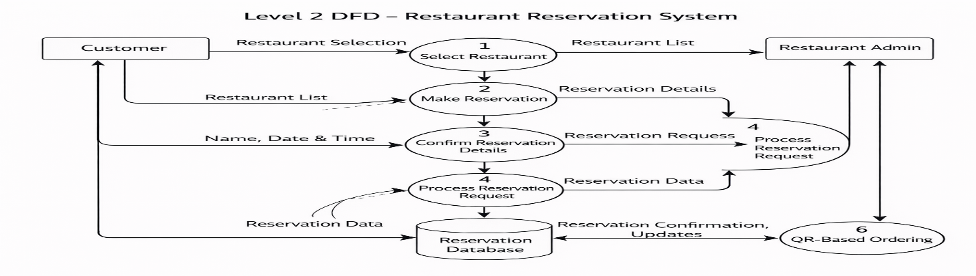
- 4. Order Management
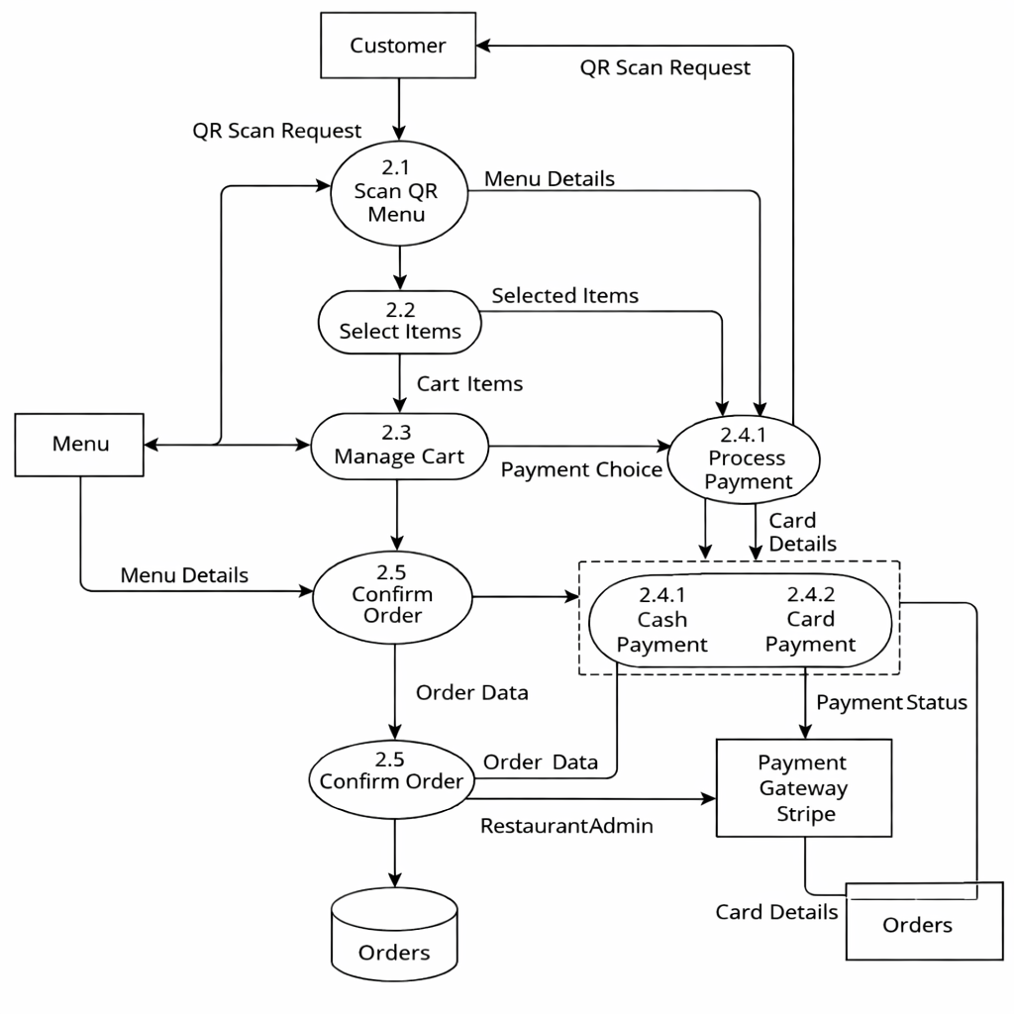
10-02-2026
- ER Diagram
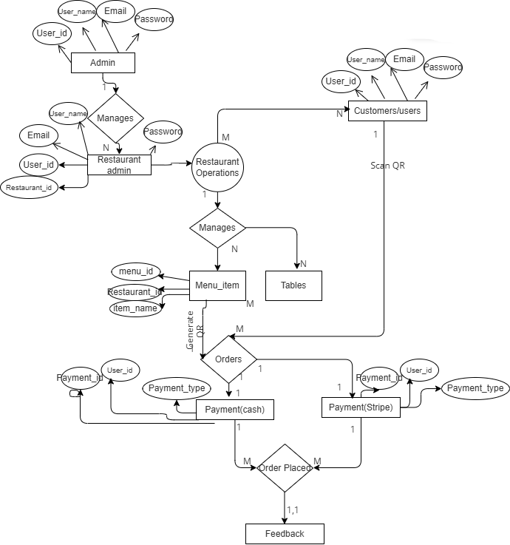
12-02-2026
- System flow chart
  - For Customer/User
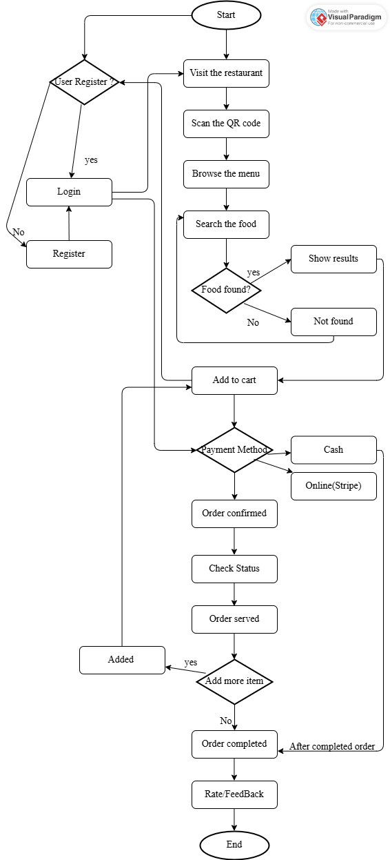
- For Restaurant Admin

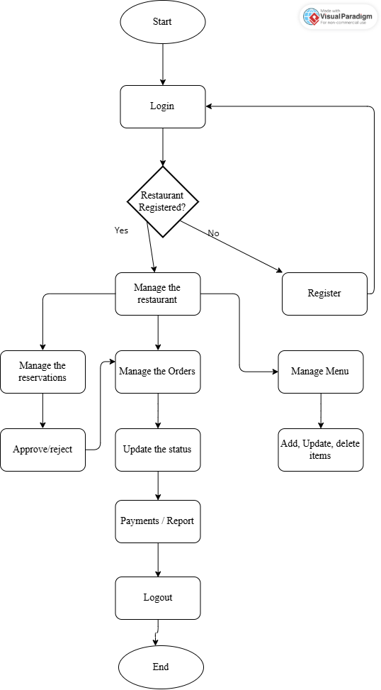
13-02-2026
- Data Dictionary of the system. Here only one is putting.
1. Users Table
- Description : Stores all the user related details in this. Role based storage of data.
Sr No | Field Name | Datatype | Constraints | Description
1 | UserId | int | Unique Identifier, Primary Key | Unique ID for all user
2 | FullName | varchar | Not Null | Name of the user
3 | Email | varchar | Not Null, Unique | Email of the user
4 | PasswordHash | varchar | Not Null | Hashed password for the authentication
5 | UserType | varchar | Not Null | Specific user: i.e Admin, Restaurant Admin, Customer
6 | RestaurantId | int | Allow nulls | References from Restaurant
7 | PhoneNumber | varchar | Allow nulls | Number of the user
8 | CreatedAt | datetime | Auto-generated | Timestamp when user was created
9 | OTP | nvarchar | Allow Null, Auto-generated | Generated when login

